# TEXTURE, TYPE & COLOUR

Type: cutted slips from solid moulded bricks

Texture: solid unsanded, smooth texture

Colour: red through and through and highly nuanced ranging from red, red-brown to purple-blue

Slips and corner slips: available on this thickness.

Other formats and thicknesses available on request.

# TECHNICAL CHARACTERISTICS

The bricks are delivered with the following characteristics, in accordance with the CE mark:**CE mark according to EN 771-1 : 2011 + A1 : 2015**

|  |  |  |
| --- | --- | --- |
| Dimensions L x W (height) x T ca. | 505x38x25 mm |  |
| Quantity/m² joint 10-12 mm ca. | 39 |  |
| Quantity/m² joint 5-6 mm ca. | 45 |  |
| Gross mass density | 1900 Kg/m³ (+/- 20%) |  |
| Water absorption (24 hours) | < 14% |  |
| Initial water absorption (1 minute) | < 4 kg/(m² . min ) IW3 |  |
| Water vapour permeability | µ = 5/10 |  |
| Thermal properties (λ10, dry, 90/90) | 0,60 W/mK (tabel 1 EN1745) |  |
| Durability (frost / thaw / resistance) | F2 – highly frost-resistant |  |
| Active soluble salts | class S2 |  |
| Fire reaction | class A1 |  |

**Brick slip specifications according to NBN B 23-004 for Belgium**

|  |  |
| --- | --- |
| Surface density joint 10-12 mm | 36 kg/m² (+/- 20 %) |
| Surface density joint 5-6 mm | 42 kg/m² (+/- 20 %) |
| Flatness | class 1 |

surface characteristics

In a sample of 100 slips, at least 95 slips will be undamaged. Are considered to be damages: every broken slip; slips with a broken corner or edge; visible cracks (< 0,2 mm) or uneven sanding or profiling, as far as these have to be considered as disturbing the visible surface of the slips. The minimum diameter of a damage is 15 mm.

The number of defected slips must not exceed 5%. The following are considered defects; the presence of hard spots which may swell and cause the slip visible surface to flake; cracks with a width ≥ 0.2 mm on the visible surface. Any damage or defects must always be reported before use.

# * With the except of burn marks that change the dimensions.

# TYPES

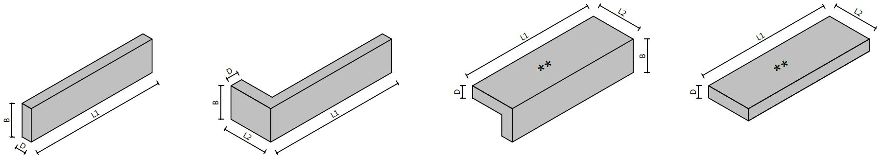

|  |  |  |  |  |
| --- | --- | --- | --- | --- |
|  | Slips |  | Corner slips (L1 = ca. 250 mm) |  |

# dimensions

|  |  |
| --- | --- |
| L1 | Ca. 505 mm (corner slips ca. 250 mm) |
| L2 | Ca. 100 mm |
| B | Ca. 38 mm |
| D | Ca. 25 mm |

# RECOMMENDATIONS

In order to create a look that is as homogeneous, the slips must be mixed correctly before processing. That means unstacking them vertically and using at least 5 different packs at the same time. If the slips come from a number of deliveries, sufficient pallets are to be kept back in order to enable the mixing of the different deliveries.

Fresh brickwork should always be protected. The slips must be dry and dust-free during installation.

Dimensions may vary depending on the production. For the most recent version see www.brickz.world. This document is not binding and annuls all previous publications. The manufacturer reserves the right to change the product range and characteristics. The user must always check that he has the most recent descriptive text.

# TRANSPORT AND STORAGE

Do not stack the packs.